Lab 3 - Security requirements

Lab Intro
In this lab session you will focus on creating and documenting security requirements for the assessment system: Scoops2Go. You will do this working within your development teams by: (1) selecting the relevant requirements from a list included in this worksheet; (2) recording and documenting these requirements using the GitHub Flow (from last week).

Learning Outcomes
By the end of this session, you will be able to:
- Demonstrate an understanding of the SPA + API architecture.
- Demonstrate an understanding of prominent Web API vulnerabilities.
- Evaluate the suitability of security requirements using the SPA + API architecture (Scoops2Go).

Resources
- Lecture 3 – APIs & The Threats They Face
- OWASP Top 10 API Security Risks – 2023 - OWASP API Security Top 10

Recap: The SPA + API Architecture
Recall the REST and SPA + API architectural styles from the lecture this week (shown in Figure 1):

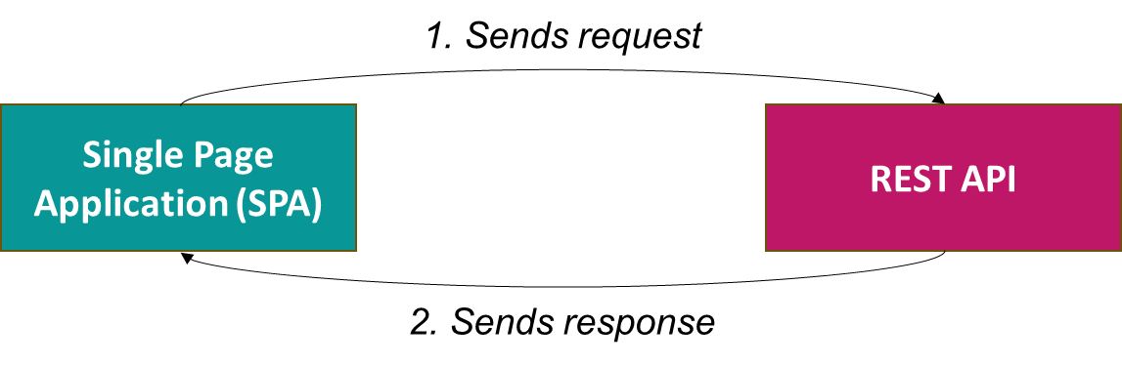
Figure 1: A high-level overview the SPA + API architectural style.
Consider the following questions in your development teams and make sure you can answer them before moving on (you can check your answers using the appendix, but ask the facilitator/tutor if anything is unclear):

- In the REST architectural style, how is the term resources defined?
- In the SPA + API architectural style, how are resource normally represented (i.e., what is their representation)?
- How does communication occur between the SPA and API components in the SPA + API architectural style (i.e., what protocol are used)?
- How is application state managed in the SPA + API architectural style?

Understanding and Questioning Scoops2Go
Scoops2Go is the system you will be developing on this module (as a part of 1CWK100). You will be doing this within your development teams and from scratch! In this section, you and your team will take your first steps on this journey by defining some security requirements for the Scoops2Go system. Naturally, these requirements will feed into the later stages of development.

Functional Requirements for Scoops2Go
You should recall from the assessment cover sheet that “…Scoops2Go has raised a significant amount of additional funds and intends to build their prototype into a fully-fledged competitor to services like Deliveroo and JustEat” – but focused on frozen treats. The functional requirements for Scoops2Go might therefore look like this:

- Users must be able to add items to their cart and customize their orders (e.g., choose a flavour, select a cone, add a topping).
- Users must be able to view their user profiles, which contain information that is personal to them (e.g., the amount they have spent on past orders).
- Admins must be able to manage users.
- Admins must be able to review all historic orders.
- Etc.

Security Questions for Scoops2Go
To build a shared understanding of Scoops2Go within your development team, discuss the security questions shown in Table 1 and use it to note your answers and thoughts. These questions are worth asking at the beginning of any development project.

Table 1: Security questions for Scoops2Go.
Security Question | Your Answer (for Scoops2Go)
Does the system contain, or come in contact with, confidential, sensitive, or Personally Identifiable Information (PII) data? | Yes. User profiles, order history, personal information.
Where and how is the data being stored? Will this application be available to the public (internet) or internally only (intranet)? | Data stored privately in data base. Application will be public on the internet.
Does this application perform sensitive or essential tasks (such as transferring money, unlocking doors, or delivering medicine)? | Yes orders and payments are the sensitive information used to this web application
Does this application perform any risky software activities (such as allowing users to upload files)? | Possibly profile pictures or user inputs
What level of availability do you need? | Normal commercial availability
Does it require 99.999% up time? (Note: almost no systems actually require that level of up time.) | Temporary downtime would impact users but extremely high availability is not required and the cost and complexity of achieving 99.999% availability outweighs the small business

Evaluating Security Requirements
Consider the security requirements listed in Table 2. These have been provided to help you start documenting security requirements for Scoops2Go as a part of your assessment. However, some of them are relevant to Scoops2Go and some of them are not… So be careful! Discuss the requirements in your development teams and determine whether or not they are relevant to Scoops2Go by putting an ‘X’ in the appropriate column. Look up any terms you’re not sure about (e.g., NSA Suite B Cryptography).

Table 2: Candidate security requirements for Scoops2Go.
Security Requirement | Relevant | Not relevant
Trust no one: validate all user input data. | X
Scan all libraries and third-party components for known vulnerabilities before use, and regularly after use (new vulnerabilities and versions are released all the time). | X
Use all applicable security headers. | X
Store all application secrets in a secret store. | X
Encrypt sensitive data using the NSA Suite B Cryptography standard. |  | x
Do not force password changes on a schedule, but only after a breach or suspicious activity. | X
Never put sensitive information in comments. This includes connection strings and passwords; those belong in a secret store. | X
Ensure all input validation (and sanitization) is performed server side, using an approved list or accepted list (not a block list) approach. | X
Ensure security testing is performed on your application before being released. | X
Ensure compliance with HIPAA regulations. |  | x
Perform threat modelling on your application before being released. | X
Perform code review (specifically of security functions) on your application before being released. | X
Ensure all errors provide generic information to the user, never information from a stack trace, query fail, or other technically specific information. | X
Implement SCADA system security protocols. |  | X
Implement maritime cybersecurity protocols. |  | X
Prefer the use of random and unpredictable values as GUIDs for records' IDs. | X
Use the authorization mechanism to check if the logged-in user has access to perform the requested action on the record in every function that uses an input from the client to access a record in the database. | X
Ensure compliance with the Sarbanes-Oxley Act (SOX). |  | X
When exposing an object using an API endpoint, always make sure that the user should have access to the object's properties you expose. | X
Identify the business flows that might harm the business if they are excessively used. | X
Be specific about which HTTP verbs each API can be accessed by: all other HTTP verbs should be disabled (e.g. HEAD). | X
Implement a proper Cross-Origin Resource Sharing (CORS) policy. | X
Adhere to NASA's Space System Protection Standard. |  | X
Deploy measures to protect from electromagnetic interference, which can disrupt communications and operations. |  | X
Ensure Compliance with CENELEC EN 5012x Standards. |  | X

Creating & Documenting Security Requirements
Note: Time in the lab might be running out at this point. Don’t worry – this next section can be completed asynchronously if needed, but it will be a good idea to discuss your approach in your development teams before leaving the lab if you intend to go down this route. It is important that you complete this section (ideally before next week) as it feeds directly into your assessment.

You should now have a list of security requirements that are relevant to Scoops2Go (from the previous task). Select one person from your development team to add these to your shared development repository using the GitHub Flow (from last week) – feel free to help them out of course:

- Follow the instructions from last weeks lab if you need to (see the “Raising a Pull Request” section).
- Name your branch: add-security-requirements (corresponds to step 6 if you’re using the instructions from last week).
- Create a SecurityRequirements.md file and put the requirements you considered relevant to Scoops2Go during the previous task into it in the form of a bullet pointed list (instead of step 9 if you’re following the instructions from last week).

Before the pull request is merged in, every team member should have the opportunity to add comments to the pull request (including the person who raised it). You might simply want to say “approved by firstName lastName” like we did last week. However, now that we’ve started working on the Scoops2Go system properly you might want to be a bit more critical. Each team member should think about one of the following points and add a comment to the pull request:

- Could any of the security requirements be improved?
  - “Ensure security testing is performed on your application before being released.” – Is this detailed enough? What kinds of security testing should be performed?
  - “Perform threat modelling on your application before being released” – Is this detailed enough? What kind of threat modelling methodology would provide the best return on investment for Scoops2Go?
- Are there any standards that might be relevant to Scoops2Go that have not yet been covered?
- Are the security requirements adequate with regards to well known vulnerabilities, like those detailed in the OWASP API Top 10?

These comments should be actioned by making further commits onto the add-security-requirements branch and including them in the pull request if necessary. After every team member has had a chance to comment on and approve the pull request, it should be merged into the main branch. – It is up to you and your team exactly how you do this.

Appendix A: Answers to SPA + API Questions
Answers to the SPA + API questions are listed below. Figure 2 from the lecture this week shows what this looks like when we put everything together.

- In the REST architectural style, how is the term resources defined? Resources are key entities that are identified by URLs (Uniform Resource Locators).
- In the SPA + API architectural style, how are resource normally represented (i.e., what is their representation)? Mainly (but not exclusively) JSON.
- How does communication occur between the SPA and API components in the SPA + API architectural style (i.e., what protocol are used)? Standard HTTP methods (e.g., GET, PUT, POST, and DELETE) are used to send requests to the API. Responses are sent to the SPA using standard HTTP status codes (e.g., 200 OK).
- How is application state managed in the SPA + API architectural style? In the REST architectural style URLs point to specific resources and help to form requests. In the SPA + API architectural style, the hyperlinks/URLs are also the engine of application state.

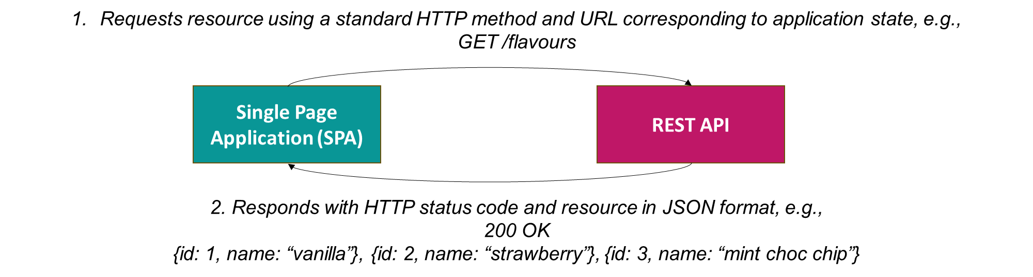
Figure 2: A more detailed overview of the SPA + API architectural style.

